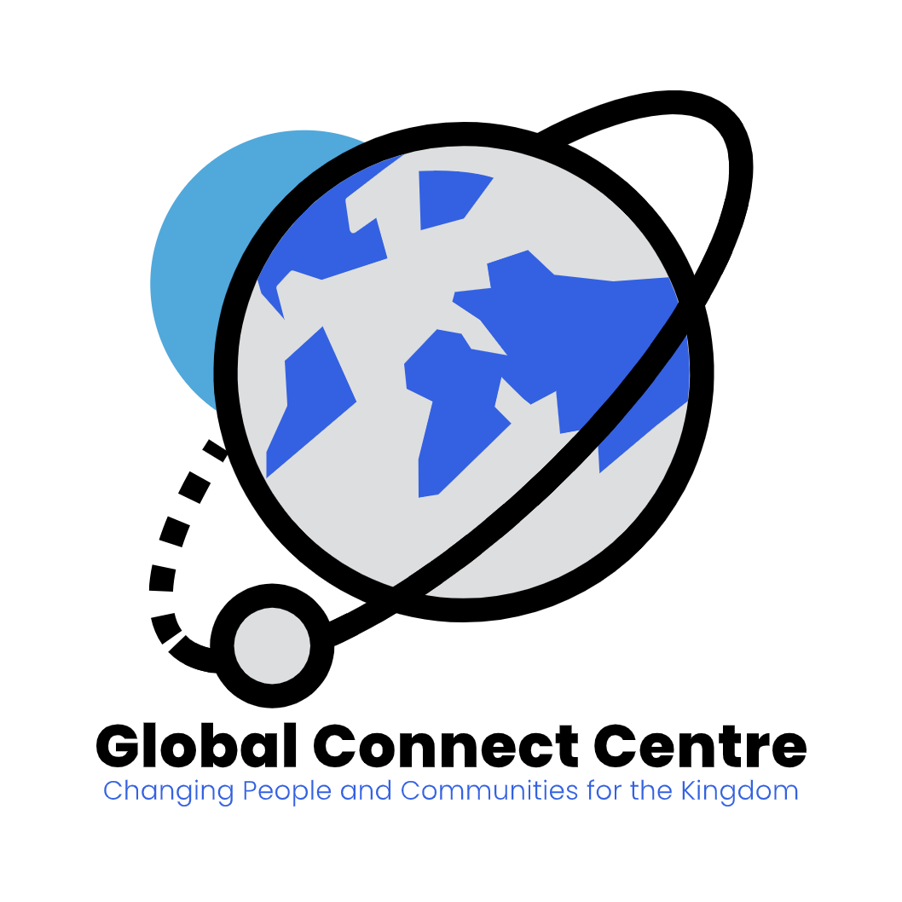

STRATEGIC PLAN
(2023-2027)

"Supporting communities in developing nations and prepare a new generation of leaders and pastors to advance the Kingdom"

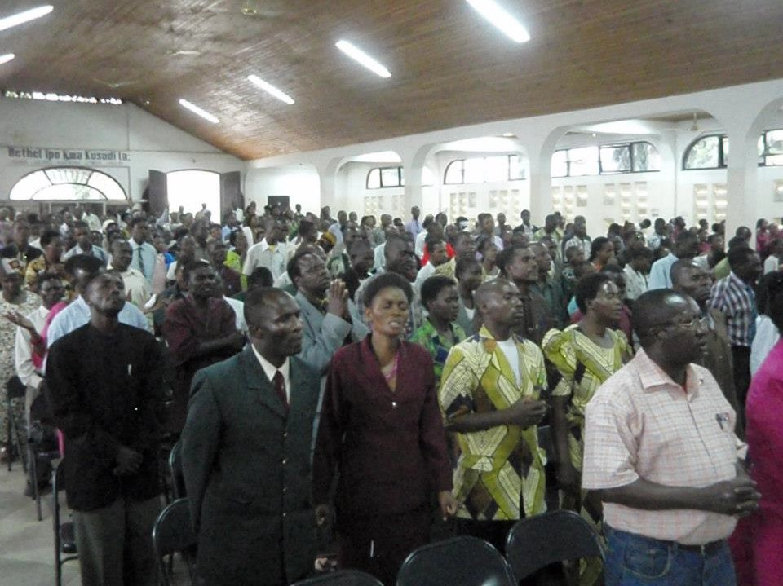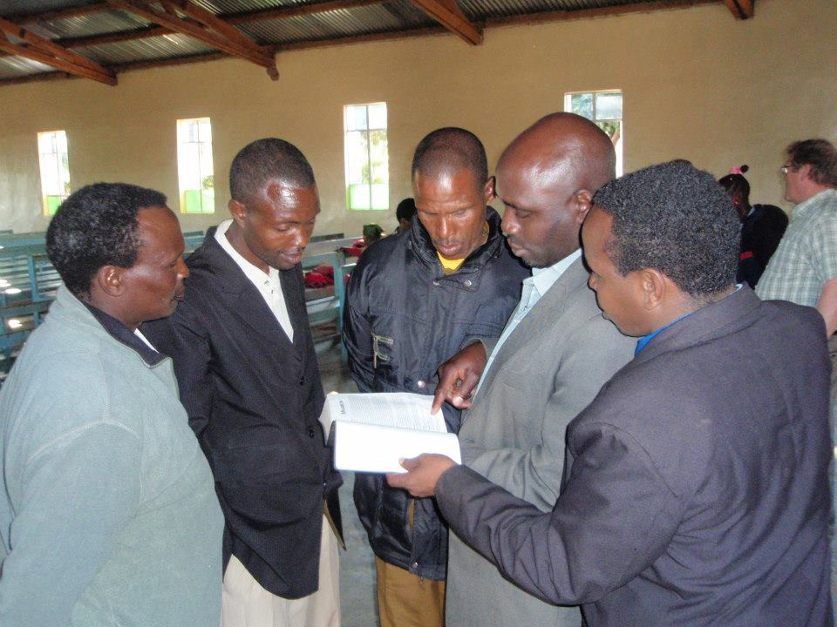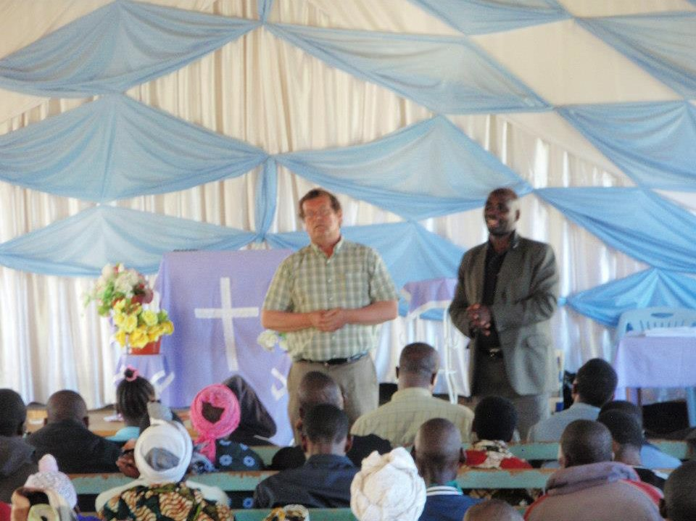

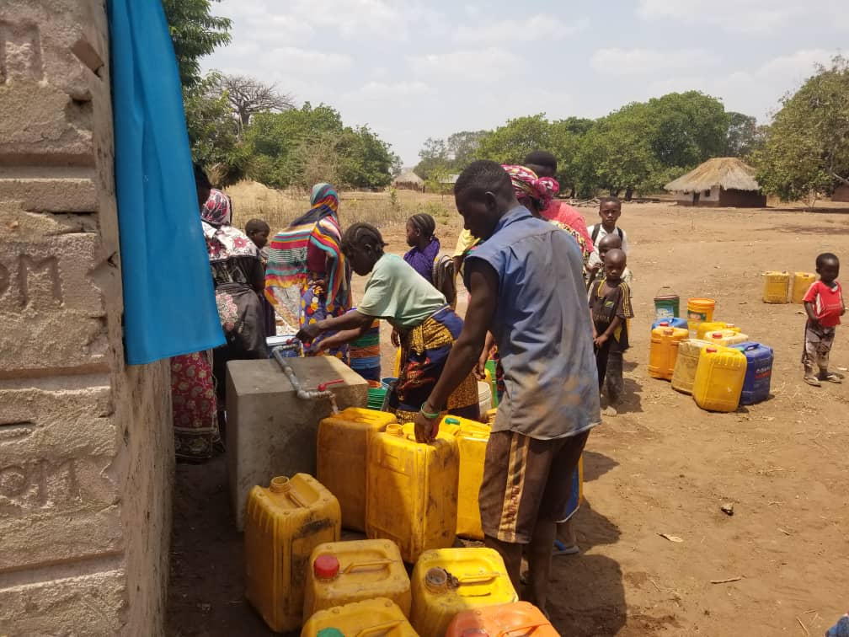
GLOBAL CONNECT CENTRE

GCC is dedicated to support communities in developing nations and prepare a new generation of leaders and pastors who are empowered by the Spirit to lead and take the gospel of Jesus Christ to every tribe, people, nation and language around the world.

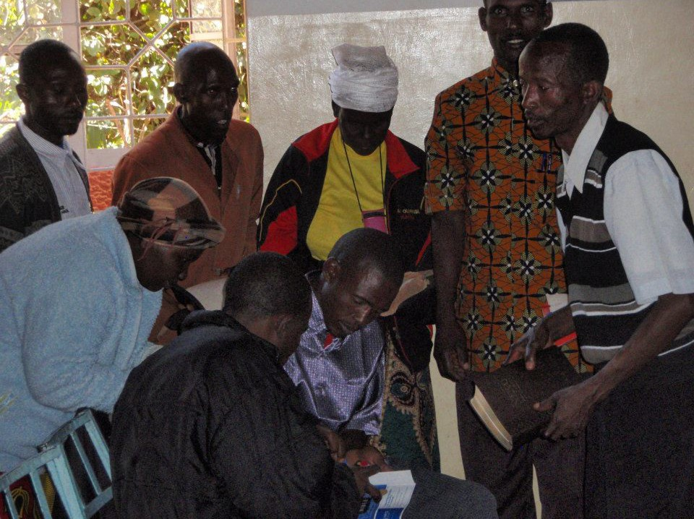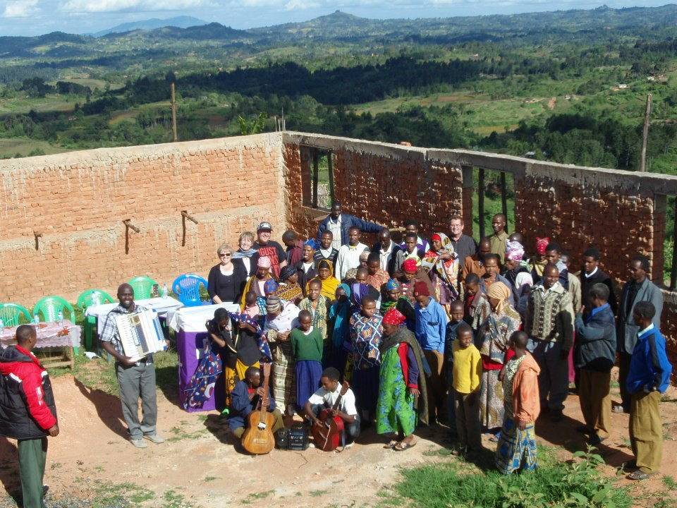

TABLE OF CONTENTS
- Our History………………………………1
- Our Mission………………………………2
- Our Values……………………………….3
- Strategic Plan: Executive Summary…....4
- Key Result Areas, Implementation Strategy and Oversight…………………5

OUR STORY
In many years, Happy and I (Boniface) have had a burden to support pastors who are struggling in ministry. We have been supporting some in Bible schools, in their daily living as well as supporting churches in different ways. Having grown up in a family where my father was a pastor who struggled a lot to support his family and ministry, I know how pastors’ families’ struggle. Happy and I have been doing this not knowing if it’s what God wanted us to do, but just because we were feeling very sorry for these pastors and wanted to do what we could to support them. Finally in the last week of February 2009, God spoke to me and confirmed to my wife that we should establish a ‘Centre’ – Pastor’s Resource Centre (PRC) to support those pastors and communities which struggle the same way my father did. In November 2021, PRC was renamed to Global Connect Centre (GCC) and registered in Canada under the Not-for-profit Corporations Act with Registration Number 1353276-3. In June 2022, GCC was granted a charitable status in Canada with Registration Number: 76387 3007 RR0001.

Throughout his years as a pastor with Pentecostal churches, my father was serving God in a very difficult and absolute poor environment (both in the family and ministry). In most cases he was just telling us, “...my children, we have nothing to eat today, let’s drink porridge and thank God...” This was happening sometimes for three consecutive days. However, my parents devoted all their lives in a ministry, using their own local knowledge and primitive equipment to run and facilitate the church ministry.
I remember most of the times he was walking a very long distance (about 60 kilometers) going up and down the hills and mountains for the ministry. Because the church didn’t have any sound equipment, my father was using his very small Phillips radio as an amplifier. Since there was no public addressing system, we had to visit the marketplace for open air crusades, and I remember one time a man wanted to punch my father when preaching at Kighare Village in Same district. I remember my father was not only pastoring but also leading the church choir and my mother singing since 1970s. My brother Pastor Aminiel played guitar with my father for many years and later my brother Joel and I joined the music team.
However, my father’s ministry and his entire life impacted us a lot. He taught us faith-how to trust and depend in God alone. Our father taught us how to offer our bodies as living sacrifices, holy and pleasing to God. He taught us the importance of abiding in truth, and he also taught us how important is to take care of the church, which is the body of Christ. At the time of his death, my father remained a myth to me, more and less than a father, pastor and servant. He died of prostate cancer in my hands on August 21, 2001, at around 2:50 am. I was in the middle of taking care of him at Same district hospital in Kilimanjaro region, hoping that he was improving, but that was the end of his faithful but struggling journey. It is this Fight, this Race and this Faith which impacted our lives and ministries. He is a prototype and role-model for our ministries. Our family has been involved in powerful ministries throughout Tanzania and beyond.

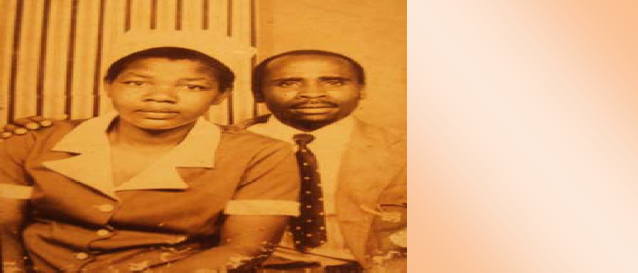
Pastor Eliamini Mgonja and his wife Elizabeth in the late 1970s where they were pastoring a church in Monduli – Arusha.

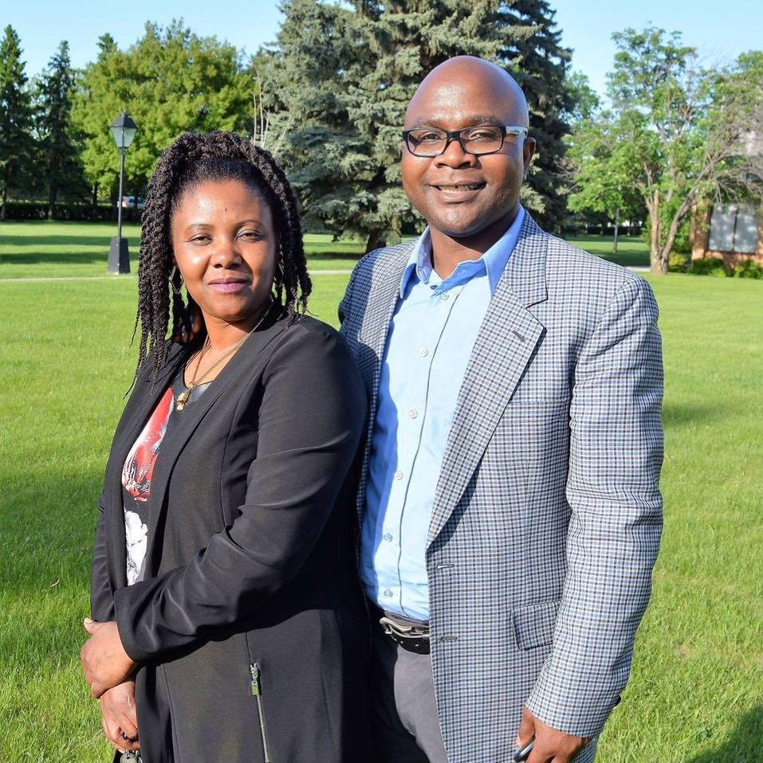
Pastor Boniface & Happy Mgonja
It is upon this foundation that God spoke to me and confirmed to my wife about establishing a Centre which will help, support, and uphold communities and pastors who struggle the same was my father did. We are so grateful to several Partners particularly Pastor John and Roberta Greiner, Dale and Donna Worthing who have come alongside this noble task of serving God’s people.

OUR MISSION
Leadership/Pastoral Development Church Support

Missions Partnership Community Support

Global Connect Centre is committed to do the followings:

Leader/Pastor Development: In partnership with different Bible Colleges or Universities, churches and individuals from all over the world, GCC will organize and conduct leadership and training seminars, workshops and conferences for pastors and leaders in order to equip them in the areas of church leadership, administration and management and advancing the gospel of our Lord and Saviour Jesus Christ to every tribe, people, nation and language around the world. GCC will organize and conduct beginners and refresher’ short courses on Bible and Theology particularly for those pastors who could not manage to attend formal Bible colleges/universities. These short courses will give them basic tools to be able to serve as effective pastors within their congregations.

Church Support: GCC will assist and equip churches mostly in rural remote areas by providing them with necessary materials and resources to be able to make disciples by reaching to communities with the gospel and new church plants. GCC will also raise matching funds for church building projects in developing nations. GCC will also provide religious books, audio visual equipment, financial assistance, and educational aids to churches.

Mission Partnership: GCC will partner with churches and missionaries around the world to fulfil the Great Commission. The partnership will range from financial assistance, dispatching missionaries and other services and equipment to reach out to communities around the world with the gospel.

Community Support: In adhering to Jesus’ commandment of “Love Your Neighbor as Yourself.” (Mark 12:31), GCC in partnership with different individuals, local and international donor organizations around the world, will facilitate different projects and programs to relieve poverty in developing nations by providing basic necessities of life, including clean water, school supplies, health and clothing to individuals or families who are poor, of low income, or in need.

OUR KEY VALUES

BIBLICALLY FAITHFUL TEAMWORK

STRATEGIC THINKING EXCELLENCE

INTEGRITY SOCIAL RESPONSIBILITY

LEADERSHIP EMPOWERMENT
Our Key Values

- In realizing our mission, we are guided by the Biblical foundation of “good and faithful servants” (Matt 25:21) in training and equipping pastors and leaders and supporting people and communities around the world.
- Strategic thinking and seeing a wider picture by understanding the dynamic environment is key in prioritizing and focusing on the areas where the need is evident.
- A quest for excellence and integrity in both actions and results of what we do is our passion.
- We partner and teamwork with reputable individuals, faith-based organizations and other institutions locally and internationally in areas of mutual interest.
- We are committed to building social responsibility programs (including but not limited to clean water, school supplies, health and clothing to individuals or families who are poor, of low income, or in need) to make a positive impact on societies locally and around the world.
- In the end, our support to communities in developing nations will be more sustainable by empowering leaders who are passionate to support their local communities by leading and taking the gospel of Jesus Christ to every tribe, people, nation and language around the world.

STRATEGIC PLAN: EXECUTIVE SUMMARY

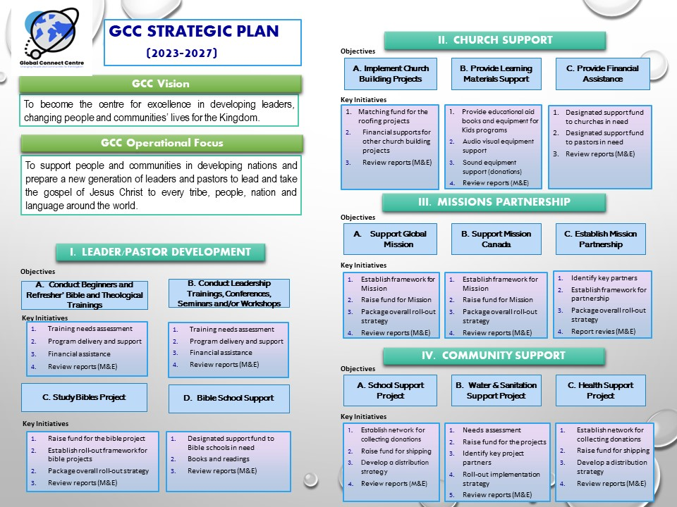

KEY RESULT AREAS, IMPLEMENTATION STRATEGY AND OVERSIGHT

A. KEY RESULT AREAS
GCC Strategic Plan is guided by three pivotal areas that have thirteen (13) key result areas that will assist in measuring the outcome.

# | Pivotal Areas | KRA | Key Results Areas
1 | Leader/Pastor Development | A | Conduct beginners and refresher’s Bible and Theological trainings
1 | Leader/Pastor Development | B | Conduct leadership trainings, conferences, seminars and/or worships
1 | Leader/Pastor Development | C | Study Bibles’ project to pastors
1 | Leader/Pastor Development | D | Bible school support
2 | Church Support | E | Implement church building projects
2 | Church Support | F | Provide learning materials support
2 | Church Support | G | Provide financial assistance
3 | Missions Partnership | H | Support Global mission
3 | Missions Partnership | J | Support mission Canada
3 | Missions Partnership | K | Establish mission partnership
4 | Community Support | L | School support project
4 | Community Support | M | Water and sanitation support project
4 | Community Support | N | Health support project

B. KEY STRATEGIC OBJECTIVES FOR EACH KEY RESULTS AREA

KRA | Key Results Areas | SG | Strategic Objective
A | Conduct beginners and refresher’s Bible and Theological trainings | Al | Conduct training needs assessment to identify training gaps.
A |  | A2 | Program delivery and support to 3 centres each year for 2,000 pastors in total in identified countries.
A |  | A3 | Raise fund to support each of the 3 conferences
A |  | A4 | Conduct review sessions, come up with a report (M and D)
B | Conduct leadership trainings, conferences, seminars and/or worships | Bl | Conduct training needs assessment to identify training gaps.
B |  | B2 | Program delivery and support to 3 centres each year for 2,000 pastors in total in identified countries.
B |  | B3 | Raise fund to support each of the 3 conferences
B |  | B4 | Conduct review sessions, come up with a report (M & E)
C | Study Bibles’ project to pastors | Cl | Raise fund to purchase 1,000 NIV Swahili Study Bibles each year
C | Study Bibles’ project to pastors | C2 | Roll-out strategies to distribute those Bibles to each graduating pastor
C | Study Bibles’ project to pastors | C3 | Establish a mechanism to purchase and distribute the Bibles
C | Study Bibles’ project to pastors | C4 | Conduct review sessions and come up with a report (M & E)
D | Bible school support | D1 | Raise fund to different biblical schools in need
D | Bible school support | D2 | Supply books and readings
D | Bible school support | D3 | Conduct review sessions, come up with a report (M & E)
E | Implement church building projects | El | Raise funds for the roofing projects
E | Implement church building projects | E2 | Financial supports for other church building projects as need arises
E | Implement church building projects | E3 | Conduct review sessions, come up with a report (M & E)
F | Provide learning materials support | Fl | Solicit and provide educational aid materials and books for Kids programs
F | Provide learning materials support | F2 | Solicit and provide auto visual equipment supports
F | Provide learning materials support | F3 | Solicit donations for sound equipment to support churches in need.
F | Provide learning materials support | F4 | Conduct review sessions, come up with a report (M & E)
G | Provide financial assistance | Gl | Support funds to churches in destitute
G | Provide financial assistance | G2 | Raise funds and assist pastors in need
G | Provide financial assistance | G3 | Conduct review sessions, come up with a report (M & E)
H | Support Global Mission | HI | Establish framework for mission support
H | Support Global Mission | H2 | Raise funds for mission
H | Support Global Mission | H3 | Package the overall roll-out strategy to support global mission
H | Support Global Mission | H4 | Conduct review sessions, come up with a report (M & E)
J | Support Mission Canada | J1 | Establish framework for mission support
J | Support Mission Canada | J2 | Raise funds for mission
J | Support Mission Canada | J3 | Package the overall roll-out strategy to support global mission
J | Support Mission Canada | J4 | Conduct review sessions, come up with a report (M & E)
K | Establish Mission partnership | K1 | Identify key mission partners
K | Establish Mission partnership | K2 | Establish framework for partnership (MoU)
K | Establish Mission partnership | K3 | Package the overall roll-out strategy for the partnership
K | Establish Mission partnership | K4 | Conduct review sessions, come up with a report (M & E)
L | School support project | L1 | Establish networks for collection of school supplies
L | School support project | L2 | Raise funds and make arrangement for shipping
L | School support project | L3 | Develop a distribution strategy at the point of destination
L | School support project | L4 | Conduct review sessions, come up with a report (M & E)
M | Water and sanitation support project | M1 | Conduct need assessment in collaboration with local partner institutions
M | Water and sanitation support project | M2 | Raise funds for identified projects
M | Water and sanitation support project | M3 | Identify key project partners both in developed and developing nations
M | Water and sanitation support project | M4 | Roll-out the project implementation strategy
M | Water and sanitation support project | M5 | Conduct review sessions, come up with a report (M & E)
N | Health support project | N1 | Establish networks for collection of school supplies
N | Health support project | N2 | Raise funds and make arrangement for shipping
N | Health support project | N3 | Develop a distribution strategy at the point of destination
N | Health support project | N4 | Conduct review sessions, come up with a report (M & E)

C. IMPLEMENTATION STRATEGY AND OVERSIGHT
Implementation Strategy
- The strategic plan outlines activities to be implemented over the next five years (2022-2027). The activities will inform development of annual work plans and budgets for each year and ensure that all the strategic objectives are addressed accordingly.
- GCC will build strategic partnerships with different stakeholders in Canada and around the world in addressing these important strategic priorities. Within Canada, GCC will collaborate with relevant development partners, churches, governmental and non-governmental organizations. At the international level, this strategic partnership will also be extended to reputable international organisations with the capacity to provide valuable contributions to the GCC’s key objectives.
- The implementation process will rely on development of an annual operational work plan, which will be undertaken for each year in a participatory manner with all GCC Board of Directors and respective donors where necessary. The annual operation plan and available funds will provide a basis for annual budgets of the GCC.
Monitoring and Evaluation (M&E)
- Successful implementation of the Strategic Plan will require monitoring and evaluation. This will assist in laying the foundation to making the necessary changes to ensure that GCC is accountable against its commitments to its own plans, donors and other regulatory authorities both within Canada and service countries.
- Reporting on implementation of the strategic plan shall be undertaken and completed on a semi-annual and annual basis, and reports shall be submitted to the Board for approval. However, project-based performance reports will be prepared annually to closely monitor the performance of each project. The annual report will include relevant audited financial information to demonstrate GCC's commitment to transparency and accountability, as part of the aspect of integrity.

GLOBAL CONNECT CENTRE (GCC)
58 - 2125 Casselman Link SW
Edmonton, Alberta T6W 3G2
CANADA
Phone: 780-220-3411
www.gconnect.ca



